**COMPUTER SYSTEMS SECURITY**

**Lab Session 03**

***Explore Web tracking***

Name: Syeda Marium Faheem

Roll No: CS-099

Section: B

**Task No.1**

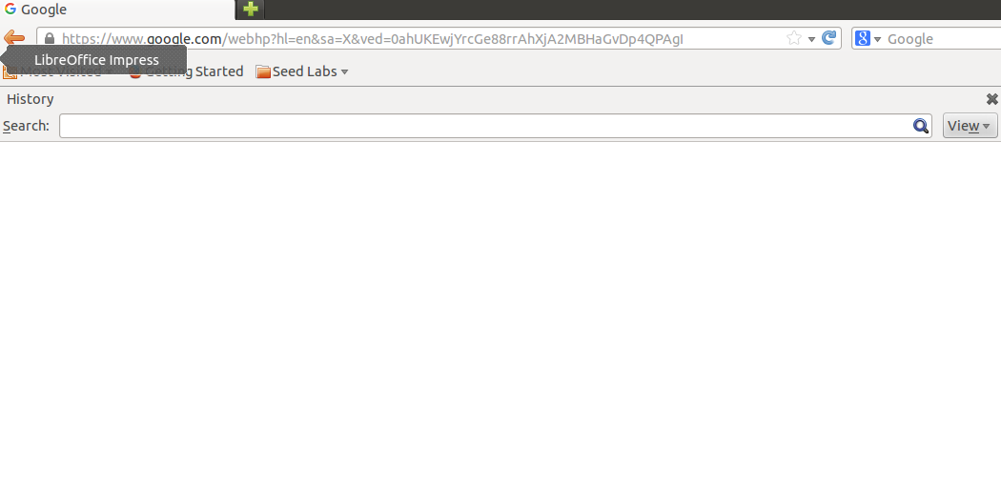

Now Open http://www.wtlabelgg.com.

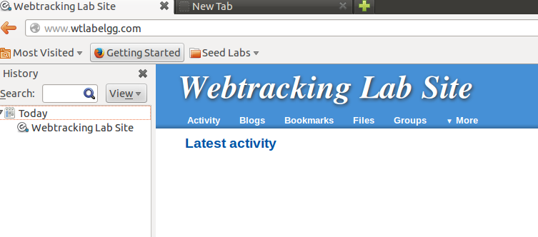

In Webstracking, recent activity added

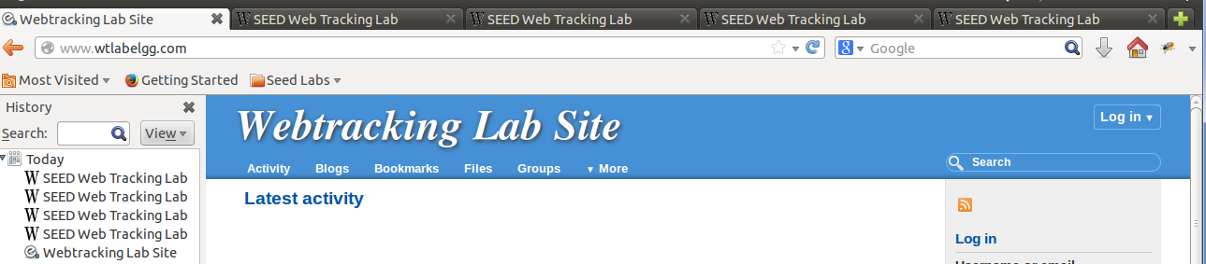

Recent Click item added on front page of Webtracking Lab Site

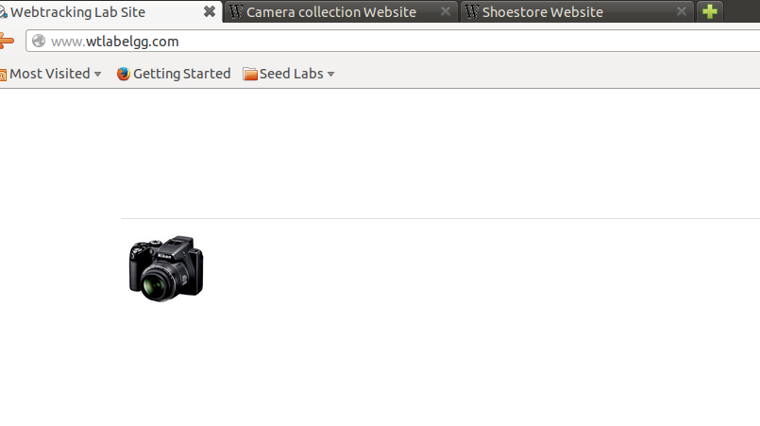

Webs tracking basically make track of recent click items or product on it main page.

**Task No.2:**

Since ,Third party cookies are cookies that are set by web site with a domain name other than the one the user is currently visiting. For example, user visits website abc.com, say the web page abc.com has an image to fetch from xyz.com. That image request can set cookie on domain xyz.com, and the cookie set on xyz.com domain is known as a third-party cookie. Some advertisers use these types of cookies to track your visits to the various websites on which they advertise.

I opened :

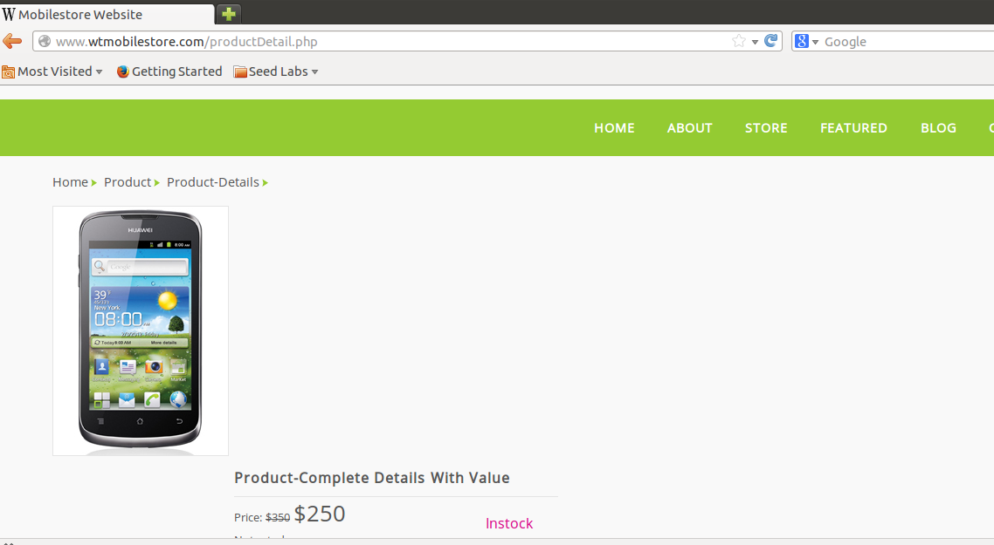

**So cookies of third party will be;**

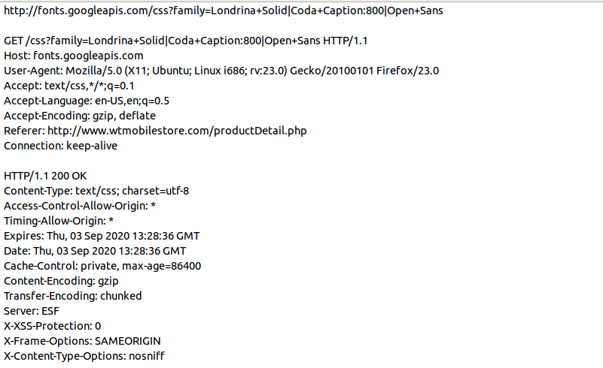

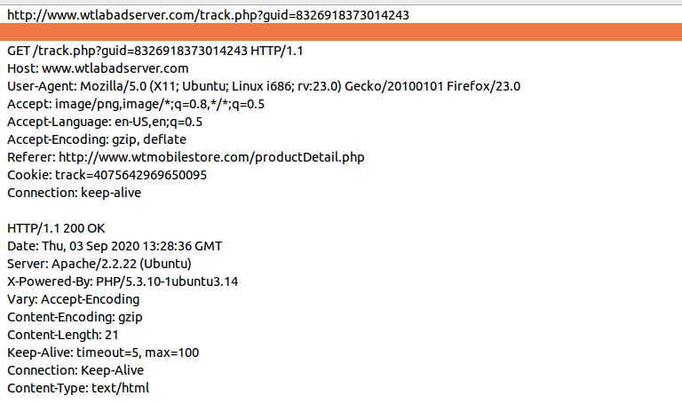

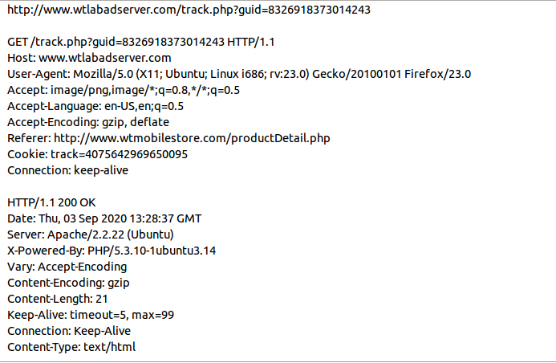

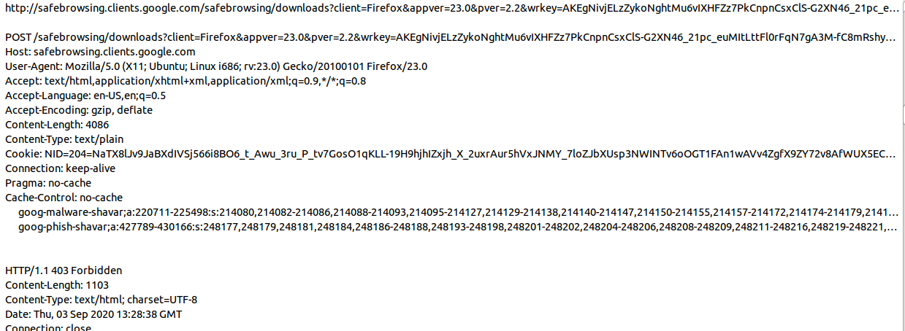

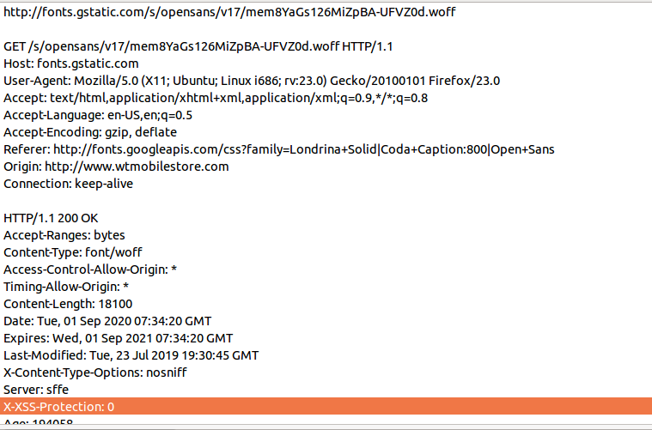

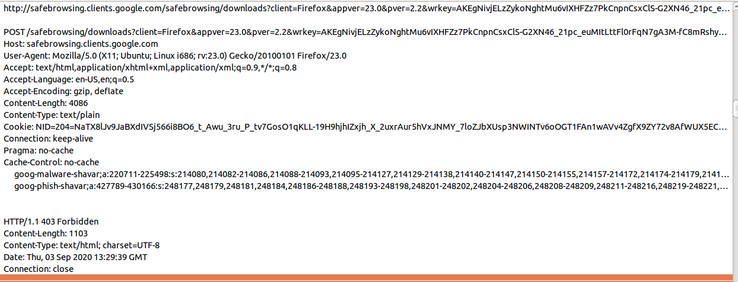

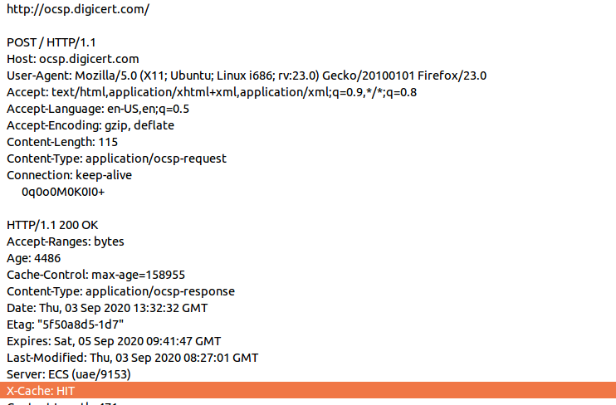

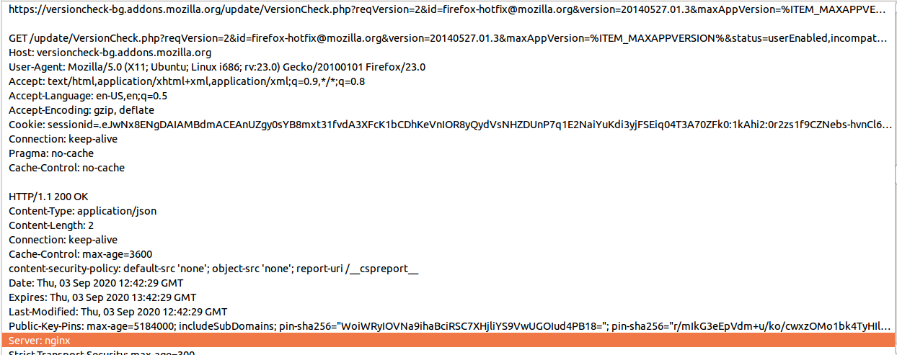

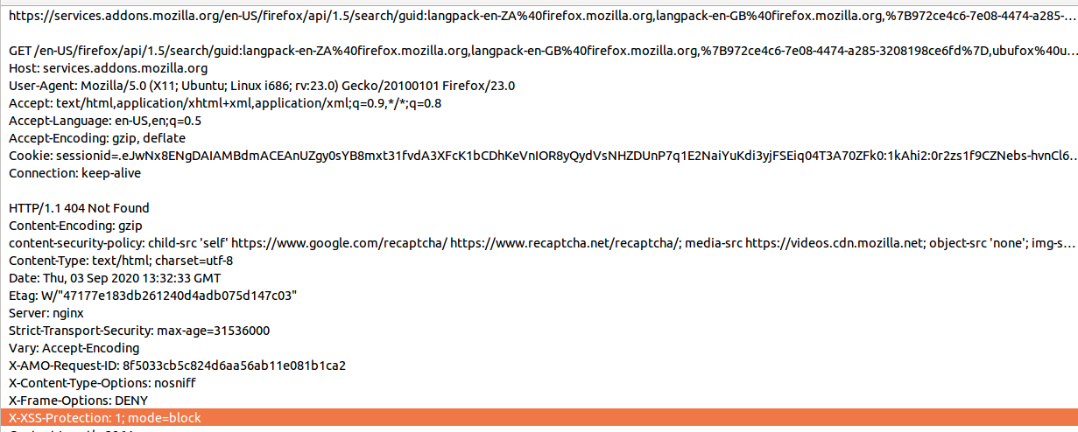

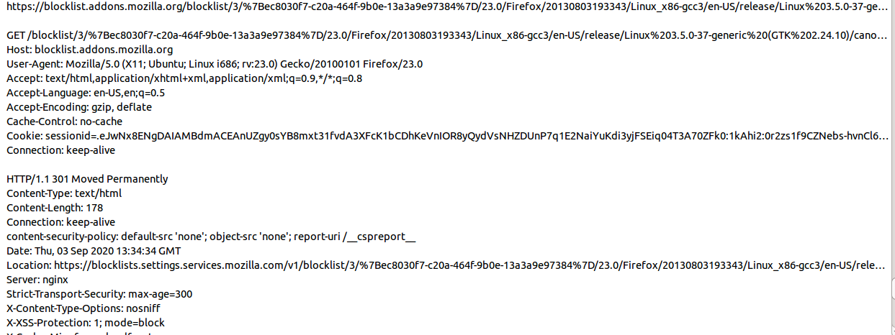

**Now View page-source**

**request for tracking cookie.**

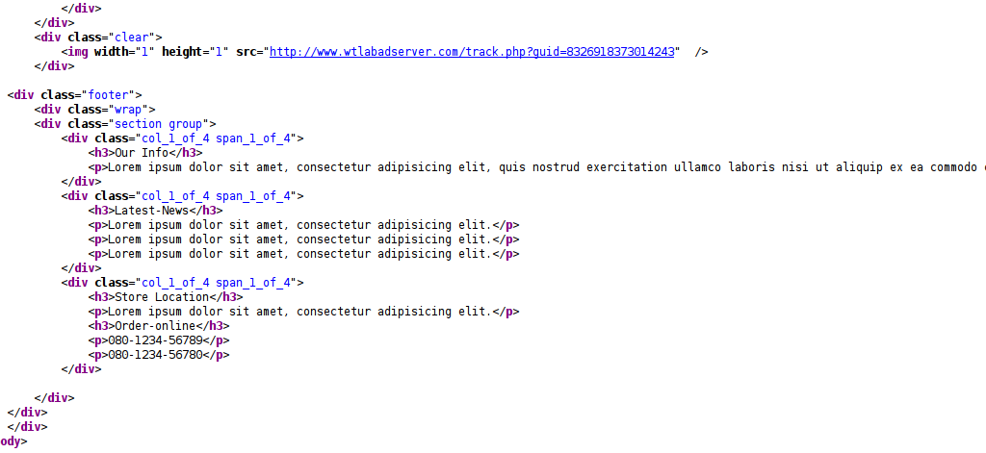

Now open http://www.wtshoestore.com/

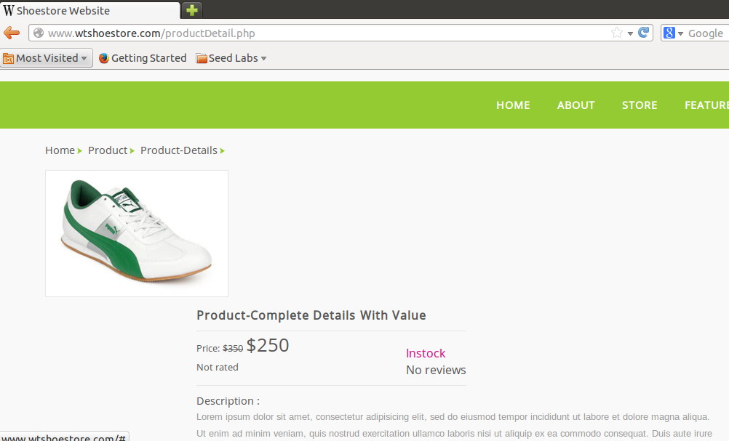

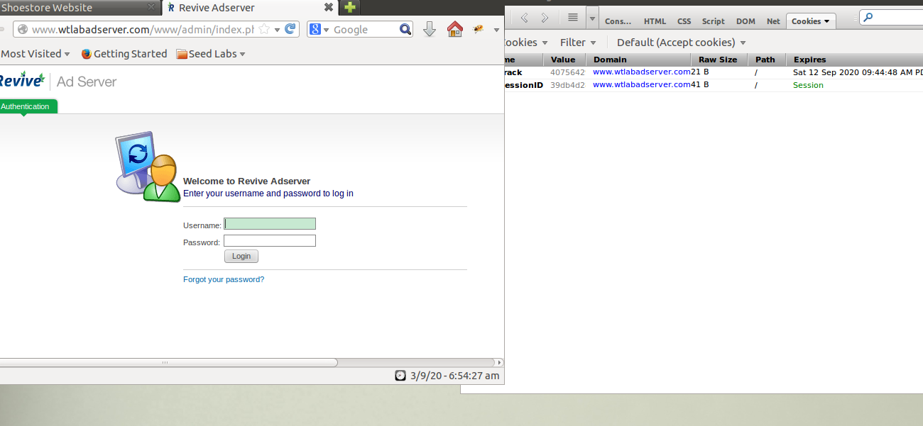

**Task no.3**

Open wtmovbilestore.com , click on item get so

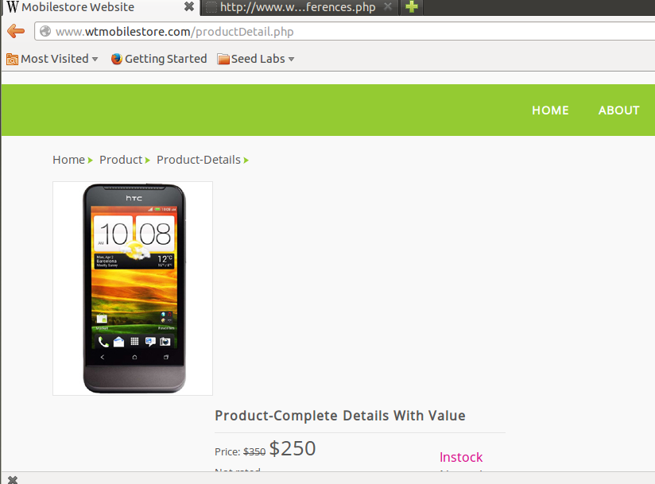

[www.wtlabadserver.com/preferences.php](http://www.wtlabadserver.com/preferences.php): This page basicaly record or maintain track of visited webiste and their items like it basically count click and impression . this page continusesly maintain track of

all clicks and impression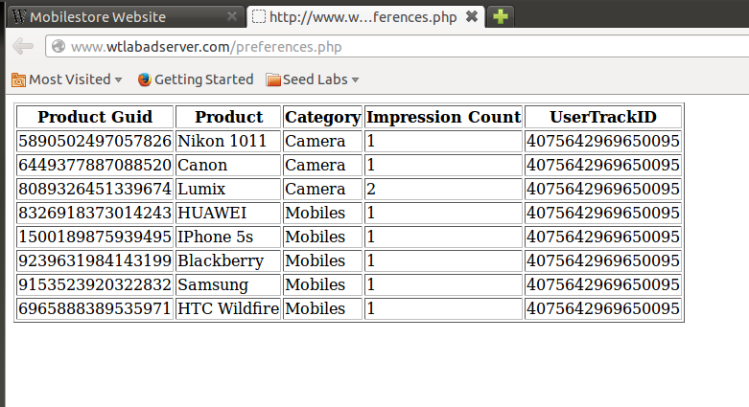

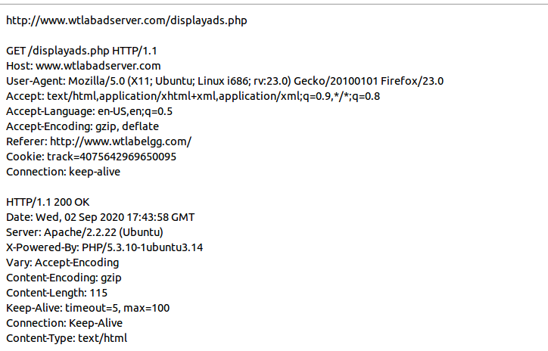**Task No.4**

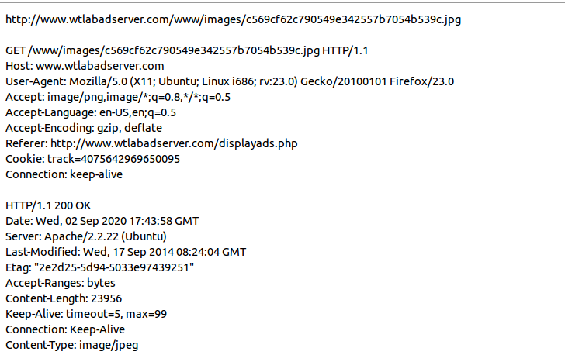

**Task No.5**

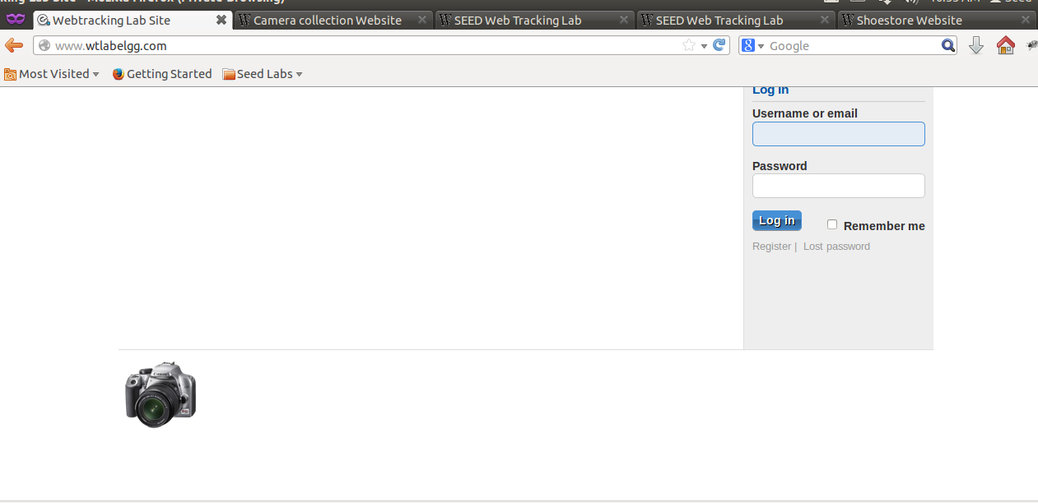

Every tie on refresh it store only current item although in task no 1. All item that were click shown here

**Task No.6:**

